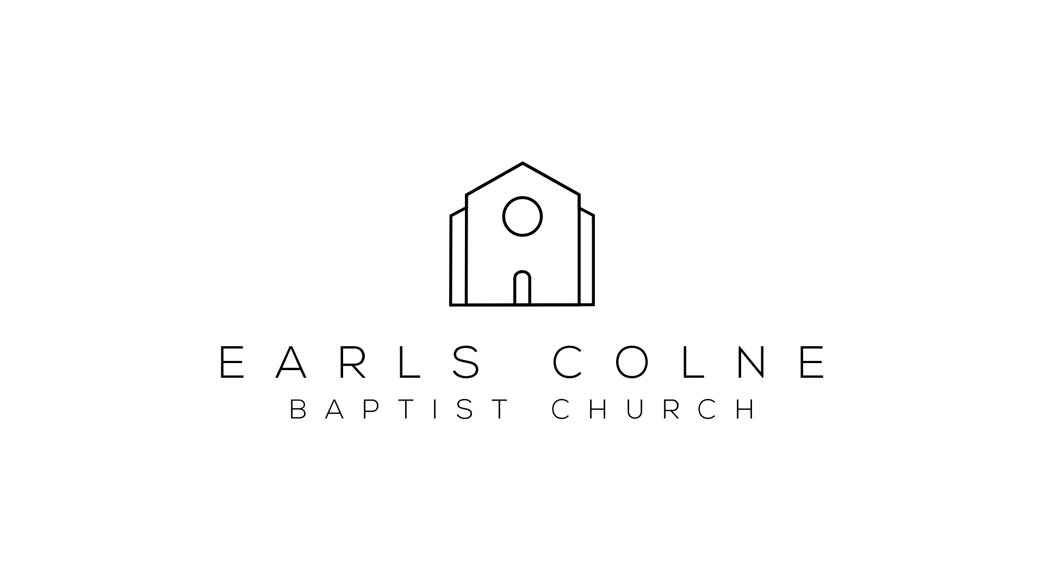

Room hire price list for Jan 2017- Dec 2017

Regular bookings:

Main hall - £10 / hour
School room and kitchen - £10 / hour
Upstairs room - £8 / hour

One-off bookings:

Main hall - £12 / hour
School room and kitchen - £12 / hour
Upstairs room - £10 / hour

Prices for hiring multiple rooms are available upon request

Please email Seven (minister) admin@earlscolnebaptist.co.uk or Frank (treasurer) Frankw259@aol.com to arrange viewings and bookings of the rooms

