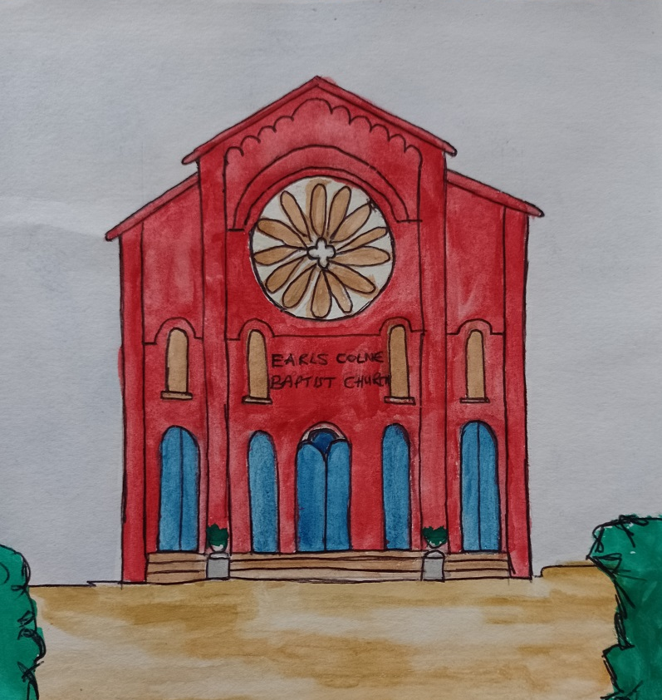
These estimates are not including extras such as scaffolding to carry out the work.
Boiler repairs:
Estimated cost = £3,000
Repair carpark + steps
Estimated cost = £15,750

Repair/repoint brick work + windows: Estimated cost £6,000
Repair/replace parapet stones
Estimated cost = £5,000
Repair/replace Guttering + downpipes:
Estimated cost £?
Repair glass in windows: Estimated cost £18,000
Repair plaster:
Estimated cost £45,000
Repair roof: Estimated cost
£30,000 - £80,000
Repair mortar flaunching with lead: Estimated cost £3,000

